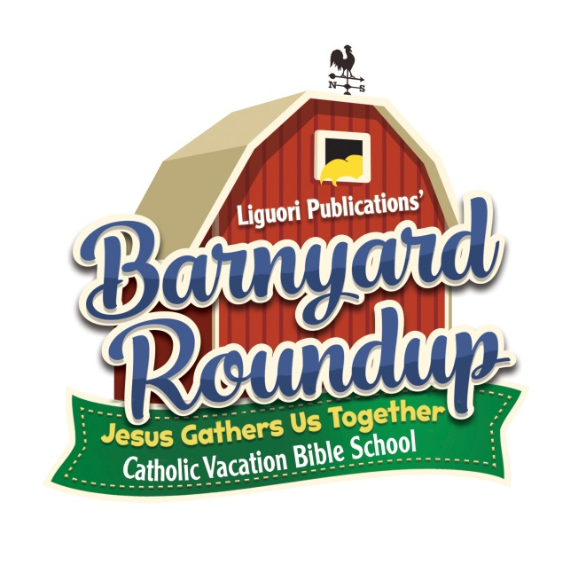
VACATION
BIBLE SCHOOL
JULY 11-15

APPLICATION TO BE A “BUDDY” FOR VBS 2016
We need a total of 6 current 6th and 7th graders] to help with VBS this year. And because the response is always greater than the need, we are implementing an application process to help with VBS 2016. To help out with VBS 2016, you have to...
† currently in 6th or 7th grade
† meet with Mrs. Liptak to talk about why you want to help out
† work with another “Buddy” with one of our teachers and a group of our little ones
† do what needs to be done for the good of our little ones
† take direction from our adult team members
† come to both meetings scheduled from 7-8pm on the following Wednesdays: June 29, July 6
† be present between 8:30 AM and 12:30 PM Mon, Tues, Wed and Thurs [July 11-15] of VBS week
† be present between 8:30 AM and 2:00 PM Fri [July 15] of VBS week

If you are ready, willing and able to commit to the above, tear off the bottom portion, fill out the application , put it in an envelope with my name on it and return in the Sunday collection– keep the top so you remind yourself of the commitment. Once I get your application, I will contact you for your interview.
Sign up for your interview early because once I fill in the teen helper slots—- no more will be added.
-Mrs. Diane Liptak
++++++++++++++++++++++++++++++++++++++++++++++++++++++++++++++++++++++++++++++++++++++++++
APPLICATION FOR “BUDDY” - VBS 2016
PLEASE PRINT LEGIBLY
NAME __________________________________________________________________________________________
ADDRESS__________________________________________________________________________________
HOME PHONE NUMBER ______________________________ CELL PHONE NUMBER _____________________
EMAIL ___________________________________________________________________ CURRENT GRADE __
My parents and I have read the above commitments and I am ready, willing and able to help with VBS 2016
_________________________________________ __________________________________________
Parent Signature My Signature
Return in the Sunday collection in an envelope marked VBS—Mrs. Diane Liptak

