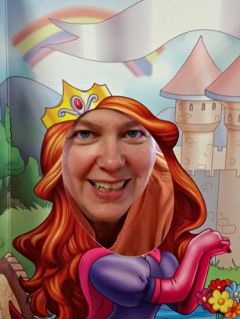
NANCY WEIL: TAKE YOUR INNER CHILD OUT TO PLAY!
MONDAY, AUGUST 8, 2016 @ 7:00 PM OUR LADY OF POMPEII PARISH 129 Laverack Avenue, Lancaster, NY 14086 716-683-6522
Taking time to let your "child out to play" can lead you to stressing less and experiencing greater joy. By getting in touch with our inner child and finding a way to communicate with this aspect of ourselves, we can end the self-sabotage, tantrums and other behaviors indicative of an unhappy inner child. Discover how to connect with your own inner child and why this one step can lead to greater self-awareness and happiness.
There is still time left this summer to commit to at least one play outing each week. What I discovered when I began doing this can help you understand why forming an Inner Child play group and having fun with your friends is so important to your health and well-being. Remember: We do not stop playing because we grow old; we grow old because we stop playing.
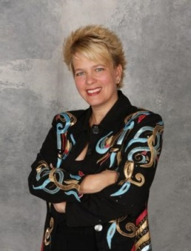
Presenter Nancy Weil is known for her energetic, entertaining and content rich programs. A national speaker, Nancy has helped thousands of people across the country change their lives through laughter and get in touch with their “inner happy.” She is the founder of The Laugh Academy and also serves as Director of Bereavement Support for the Catholic Cemeteries, Diocese of Buffalo. Nancy is the author of the book If Stress Doesn’t Kill You, Your Family Might.

Nancy was very well received at OLP when she did, LAUGHTER IN THE FACEOF TEARS! We wholeheartedly WELCOME HER BACK!

