The Prophets: Messengers of God's Mercy Catholic Bible Study

Our Lady of Pompeii Ministry Center 129 Laverack Avenue, Lancaster, NY 14086 www.olpparish.com 716-683-6522

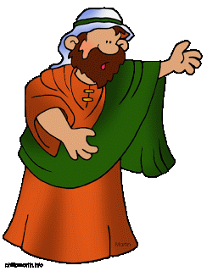

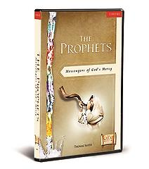
In these ten 30-minute DVD presentations Thomas Smith and Sarah Christmyer provide an overview and explanation of the prophets. Sessions take place on the following Tuesdays 6:30 – 7:30 PM:
- Introduction to the Prophets (October 3, 2017)
- Hosea: Living God’s Love Story (October 17)
- Jonah: God’s Reluctant Messenger (November 7)
- Isaiah Part 1: Prophet of Woe (November 21)
- Isaiah Part 2: Prophet of Consolation (December 5)
- Jeremiah: The Broken-Hearted Prophet (January 9, 2018)
- Ezekiel: God’s Watchman on the Wall (January 23)
- Daniel: Faithful to the End (February 6)
- Haggai and Malachi: Messengers of Hope (February 20)
- New Testament and Modern Prophets: Messengers of the New Covenant (March 6) Note: SNOW DAY - 3/20/2018 (Closing info: CH 4WIVB/WNLO & CH 7 WKBW)
In The Prophets You Will:
- Discover who the prophets were, what their message was, and why they are important to us.
- Discover the areas in your life that prevent you from drawing closer to God.
- Understand how the central message of the prophets is one of love, proclaiming the mercy of God for his children.
- See how their powerful words speak to us today, shedding light on our faith and our lives.
- Discover the ways you are called to be the voice of God to others. ...and much more!
***PROPHETS $5.00 Registration fee DUE: SEPTEMBER 11, 2017*** (Drop in collection basket or mail to Our Lady of Pompeii, 158 Laverack Ave, Lancaster, NY 14086 ATTN: SR JOYCE)
NAME ____________________________________ EMAIL __________________________________
ADDRESS __________________________________ PHONE _________________________________
__________________________________ PARISH _________________________________
PAYMENT: Cash_____ Check ______ Amount _________ Note: Couples pay only one 5.00 fee (not 2)
How did you hear about us? _________________________________________________________________

