VACATION BIBLE SCHOOL 2017
July 10-14
9 AM – 12 Noon
Our Lady of Pompeii Ministry Center
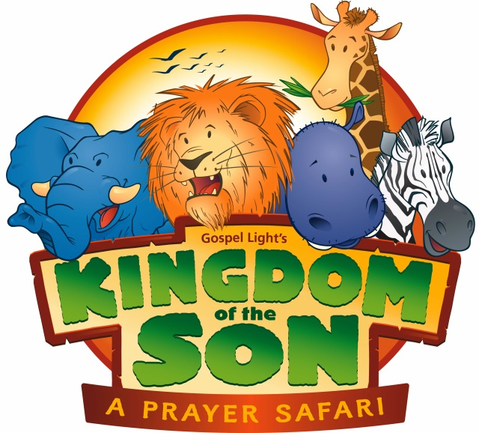
Children Ages 5 – 12
(Grades Pre-K – 6)
$15 per child for the week
$40 per family

Complete the form below and return in
the Sunday collection or to the Rectory

Limited to 100 children
Paid registration assures your place
------------------------------------------------------------------------------------------------
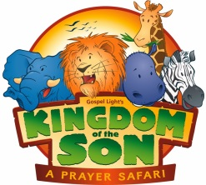
\VACATION BIBLE SCHOOL 2017
REGISTRATION FORM
July 10-14
9 AM – 12 Noon
Our Lady of Pompeii Ministry Center

CHILD’S NAME (First and Last) ________________________________________________________________
CHILD’S PREFERRED FIRST NAME _____________________________________________________________
ADDRESS _________________________________________________________________________________
PHONE ___________________________________________________________________________________
YOUR EMAIL ______________________________________________________________________________
AGE ________________________________ GRADE AS OF SEPTEMBER 2017 _________________________
CIRCLE T-SHIRT SIZE: CHILD: SMALL MEDIUM LARGE +++ ADULT: SMALL MEDIUM LARGE
FOOD ALLERGIES? _________________________________________________________________________

