***Calling All WOMEN***



**to join our *Women’s Spiritual Book Club* today!**

Our Lady of Pompeii Parish Ministry Center 129 Laverack Ave, Lancaster, NY 14086 716-683-6522 www.olpparish.com

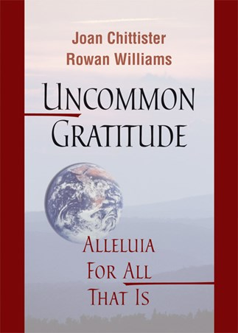

**Women’s Book Club Response Form (Return by September 8, 2017, please.)**

**Drop in collection or mail to: Our Lady of Pompeii, 158 Laverack Ave, Lancaster, NY 14086, ATTN: S Joyce**

**NAME _______________________________ EMAIL ___________________________**

**ADDRESS ____________________________ PHONE _________________________ ____________________________ PARISH _________________________**

**How did you hear about us? _____________________________________________**

**EMAIL ADDRESS _______________________**

**ISBN-13: 9780814649053**

**DATES:** OCT 30, 2017, NOV 20, DEC 18, JAN 22, 2018, FEB 12, MAR 12, AP 23, MAY 21 (SNOW DAY: June 11 - Closing info: CH 4 WIVB/WNLO & CH 7 WKBW)

A soul-stretching book by two contemporary prophets… Alleluia for Joan Chittister and Rowan Williams for this inspiring and timely message of hope in the midst of so much fear and violence. A faith filled and prophetic perspective on the dark and hurting spaces in our world and lives. We are both invited and challenged to pick up our pieces, dry our tears, shake ourselves down, and continue the journey with renewed hope and joy. Alleluia indeed. (Edwina Gateley, Poet, writer, international speaker, and women’s advocate)

***FIRST SESSION:***

**MONDAY OCTOBER 30, 2017**

**6:30 - 7:30 PM**



Following meetings are One Monday per month Oct-May.