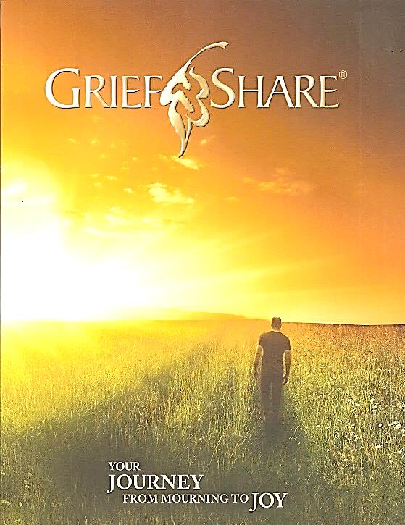

***(Kindly register by September 11th if possible.)***

***(DATES AND SCHEDULE ON OTHER SIDE.)***

**It’s a place where you can be with people who understand the pain of your loss and how you feel. DVD Presentations are given by Grief Experts who will share their personal stories of loss, giving inspiring lessons on how to make The Journey from Mourning to JOY! (13 Sessions are listed on the back of this sheet. Counselors are present to lead discussion at each session.) Register today!**

**GRIEFSHARE REGISTRATION FORM & $5.00 FEE Drop in OLP Collection or Mail to: Our Lady of Pompeii Church, 158 Laverack Ave, Lancaster, NY 14086 (ATTN: SISTER JOYCE)**

**NAME _____________________________________ PARISH _____________________________________**

**ADDRESS __________________________________ EMERGENCY CONTACT & # ____________________**

**___________________________________________ CONTACT’S NAME ____________________________**

**PHONE ____________________________________ E-MAIL ______________________________________**

**WHOM HAVE YOU LOST IN DEATH? [relationship(s) & name(s)___________________________________**

**WHEN DID THE LOSS OCCUR? ______________________________________________________________ ENCLOSED ($5.00) Cash_________ or Check # ________ Couples pay only 5.00 (Payable to Our Lady of Pompeii)**

**How did you hear about our program? ________________________________________________________________**

Wednesday, OCTOBER 11, 2017 6:30 – 8:15 PM

**(2 Wednesdays per month) Questions? Call Sister Joyce King @ 683-6522 X103**

***GRIEFSHARE:* A supportive group, when you have lost someone dear.**

**Our Lady of Pompeii Parish Ministry Center**

**129 Laverack Avenue Lancaster, NY 14086 www.olpparish.com (Corner of Sheldon & Laverack)**