Our Lady of Pompeii Church
129 Laverack Avenue
Lancaster, New York 14086
Deacon Greg Feary
683-6522 ext. 106
deacon.greg@olpparish.com
Daytime @ OLP

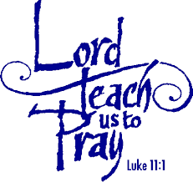
These words from Jesus’ disciples as recorded in Luke’s gospel are the same words from disciples to this day at some point in our spiritual journey. We all want to have a deeper relationship with God but at times we have gone dry in the way of prayer we have been used to, been away from a prayer relationship or perhaps feel as though my prayer is not effective. This very practical seminar is just for you!
Join us for five weeks as we explore what prayer is [and is not], where your prayer style is at this point in your life and practice the various forms of prayer from both traditional and the contemporary scenes.
Two sessions will be offered.
Thursdays from 10:00 -11:30 am ~OR~ 1:00 – 2:30 pm according to the schedule below.

Session Schedule
Date | Topic
May 30 | What Prayer is and What Prayer is Not  My Prayer Style
June 6 | Searching Prayer
June 13 | Experiential Prayer
June 20 | Relational Prayer
June 27 | Innovative Prayer
ALL SESSIONS ARE HELD IN THE
ST. STEPHEN ROOM OF THE MINISTRY CENTER

QUESTIONS OR TO REGISTER
Contact Deacon Greg [information above]

