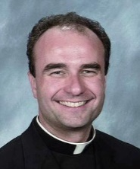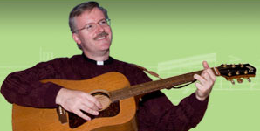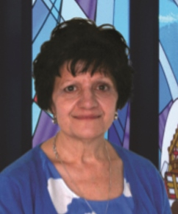****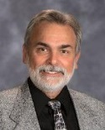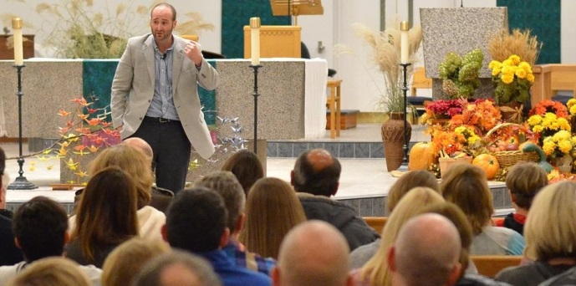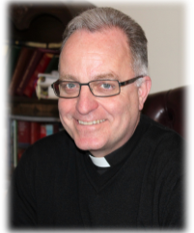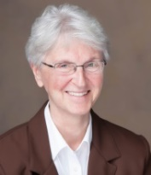****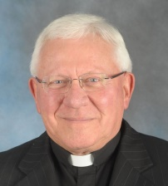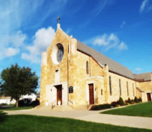

**FORGIVEN** Return in Sunday collection or to the parish office **ATTN: SISTER JOYCE.**

Name __________________________________ Phone _________________________

**Breakout Sessions** **[You have a choice of TWO; Circle TWO**] **Forgive Others Forgive the Church Forgive Yourself** **Forgive Your Past Asking for Forgiveness**

7:00 p.m. Our Lady of Pompeii RC Parish 129 Laverack Ave. Lancaster, NY 14086 [www.olpparish.com](http://www.olpparish.com) 716-683-6522

**FORGIVEN** Return in Sunday collection or to the parish office **ATTN: SISTER JOYCE.**

Name __________________________________ Phone _________________________

**Breakout Sessions** **[You have a choice of TWO; Circle TWO**] **Forgive Others Forgive the Church Forgive Yourself** **Forgive Your Past Asking for Forgiveness**

Monday, February 10, 2020 (Rev. Msgr. David LiPuma) **THE VENERABLE NELSON BAKER/ “FATHER BAKER”: THE TRUE STORY BEHIND HIS LIFE AND LEGACY**

Monday, January 13, 2020 (Sister Francesca Buczkowski) **LIFE’S SACRED PLACES SHAPE OUR RELATIONSHIP WITH GOD**

Monday, May 18, 2020 (Rev. Bill Quinlivan)  **“SONGS FOR THE SOUL” CONCERT: 7-8 PM.**

**GOD CAN MAKE ANYTHING NEW: DEALING WITH LIFE TRANSITIONS IN LIGHT OF THE RESURRECTION**

Monday, April 20, 2020 (Renee Villa)

Monday, November 18, 2019 (Deacon Bill Walkowiak) **REVELATIONS OF THE** ***CAMINO DE SANTIAGO* (Insights & Visuals of his 5oo mile pilgrimage across Spain)**

7:00 PM Free Monthly Faith Enrichment Series 2019-2020

**BRING A SIDE DISH OR SNACK TO SHARE!**

**THREE-DAY PARISH MISSION: “SURGE OF THE HEART”**

**By JON LEONETTI: Nationally known Catholic speaker, best-selling author and radio host!**

**MARCH 9, 10, 11, 2020 @ 7:00 p.m.**

**ST. MARTHA CHURCH, 10 French Rd, Depew, NY 14043**

Co-Sponsored by Our Lady of Pompeii, St. Mother Teresa of Calcutta, St Mary of the Assumption, and St. Martha Parishes **Attend all or some sessions. Free Will offering welcomed!**

Monday, October 21, 2019 (Rev. Leon Biernat) OLP Church **“GO MAKE DISCIPLES…” WHILE LIVING IN A CULTURE OF DEATH**

*Monday, September 23, 2019 (Local Deacons) OLP Ministry Center **FORGIVEN**  (*RSVP below for *break-out sessions*.)

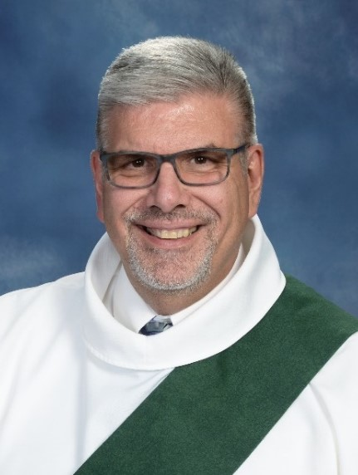

Monday, December 16, 2019 (Rev. Msgr. Frederick Leising)  **ADVENT AND CREATION: WHO IS GOD? WHO ARE YOU?**

Our Lady of Pompeii Parish 129 Laverack Ave, Lancaster, NY 14086 (716-683-6522) www.olpparish.com Refreshments follow each event! All are welcome!

**HOT DOGS PROVIDED AT 6:30 PM**