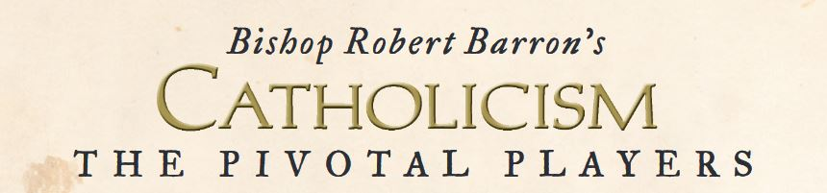

REGISTER ON OTHER SIDE OF THIS SHEET.

HOPE YOU WILL JOIN US!

Sister Joyce

**ST FRANCIS OF ASSISI: *The Reformer*** OCTOBER 8, 2019 Part I (30:32) OCTOBER 22, 2019 Part II (26:30)

**ST THOMAS AQUINAS: *The Theologian*** NOVEMBER 5, 2019 Part I (34:03) NOVEMBER 19, 2019 Part II (28:08)

**ST CATHERINE OF SIENA*: The Mystic*** DECEMBER 3, 2019 Part I (22:44) DECEMBER 17, 2019 Part II (31:05)

**BLESSED JOHN HENRY NEWMAN: *The Convert*** JANUARY 7, 2020 Part I (30:55) JANUARY 21, 2020 Part II (27:39)

**G.K. CHESTERTON: *The Evangelist*** FEBRUARY 4, 2020 Part I (27:10) FEBRUARY 18, 2020 Part II (27:24)

**MICHAELANGELO*: The Artist*** MARCH 17, 2020 Part I (42:50) MARCH 31, 2020 Part II (32:50)

**ST AUGUSTINE: *The Teacher*** APRIL 14, 2020 Part I (29:42) APRIL 28, 2020 (25:56)

**ST BENEDICT: *The Monk*** MAY 12, 2010 Part I (21:38) & Part II (35:47)*

**SNOW DAY: MAY 19, 2020 *If no snow day, perhaps St Benedict Part II on this date.**

**(Closing info: CH 4 WIVB/WNLO & Ch 7 WKBW)**

**6:30 PM Our Lady of Pompeii Schedule:**