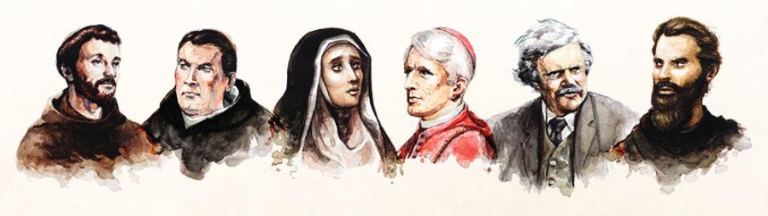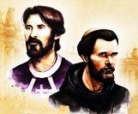

**INFO: 716-683-6522 www.olpparish.com**

2 Sessions per month.

(Oct-May)

Schedule on back.

**Volume II**: **St. Augustine, the Teacher**, is possibly the best example of how faith in Christ changed a person. Augustine’s narrative of personal transformation in his book *Confessions* provides a template for life in Christ that still rings true today.

Many would argue that **St. Benedict, the Monk**, contributed more to saving western Christian culture than anyone else. Born just after Rome fell, Benedict founded the religious community that would, in time, preserve the best of the old and allow for the emergence of an authentic, Christian way of life.

Join

**Pivotal Players I & II** showcase a handful of saints, artists, mystics, and scholars who not only shaped the life of the Church but changed the course of western civilization. Journey with Bishop Barron to explore the lasting influence of these Pivotal Players.

**Our Lady of Pompeii Ministry Center, 129 Laverack Ave, Lancaster, NY 14086**



**Session 1 TUES, OCT 8, 2019 6:30 – 7:30 PM**

**Volume I:** You'll discover the places where **St. Thomas Aquinas** lived, learned, and wrote. Visit the countryside where **St. Francis** gathered a group of friars and revived the Church. See the places where **St. Catherine of Siena** ministered and prayed. Trek through England to where **Bl. John Henry Newman** and **G.K. Chester**ton left their mark and sparked an English Catholic revival. And through unprecedented HD footage, marvel at the extraordinary art of **Michelangelo**, from his David statue in Florence, to the Pietà at St. Peter's, to the Sistine Chapel.

**\*\*\*PIVOTAL PLAYERS Volumes I & II = $5.00 Registration fee DUE: SEPTEMBER 12, 2019 if possible.\*\*\*** (Drop in collection basket or mail to Our Lady of Pompeii, 129 Laverack Ave, Lancaster, NY 14086 ATTN: SR JOYCE)

NAME ____________________________________ EMAIL __________________________________

ADDRESS __________________________________ PHONE _________________________________

__________________________________ PARISH _________________________________

PAYMENT: Cash_____ Check ______ Amount _________ Note: **Couples** pay only one $5.00 fee (not 2)

How did you hear about us? _________________________________________________________________